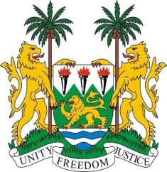
SIERRA LEONE
22nd Session of the UPR

CROATIA

Statement by Ambassador Yvette Stevens

12 May 2015

Mr President,

Sierra Leone welcomes the delegation of the Croatia and thanks them for their comprehensive report.

My delegation commends the government for the creation of the National Programme for the promotion and protection of human rights (2013 -2016), and for drawing up policies and strategies, including the National Strategy for the rights of children (2014 – 2020), National Strategy for Protection against Family Violence (2011 – 2016) and the National Health Care Strategy (2012 – 2020). These documents provide the blueprints for action.

However, my delegation notes, with concern the inadequate human and financial resources made available for the implementation of human rights commitments. My delegation would also urge Croatia to further facilitate the participation of women, in particular those from minority groups in the socio-political spheres their integration into the labour market, to address the de facto discrimination prevalent against children in marginalized and disadvantaged situations.

Sierra Leone also calls on Croatia to submit its long overdue reports to the CESCR and CERD.

Sierra Leone would like to offer the following recommendations:

- Accede to the ICRMW and intensity efforts to ratify the ICPPED.
- Increase the human and financial resources made available to the office of the Ombudsperson to enable it to fulfil its expanded mandate.
- Develop a policy, strategy and action plan to address the reportedly widespread violence against women.

Sierra Leone would like to conclude by wishing Croatia a successful completion of their UPR.

Thank you, Mr President.

